**Date:** 19.8.24

**ANALYZE NETWORK TRAFFIC USING WIRESHARK TOOL**

**AIM:**

To capture, save, filter and analyze network traffic on TCP / UDP / IP / HTTP / ARP /DHCP /ICMP /DNS using Wireshark Tool

**1. Capture 100 packets from the Ethernet: IEEE 802.3 LAN Interface and save it. Procedure**

∙ Select Local Area Connection in Wireshark.

∙ Go to capture option

∙ Select stop capture automatically after 100 packets.

∙ Then click Start capture.

∙ Save the packets.

**Output**

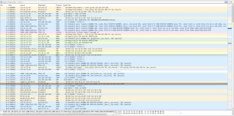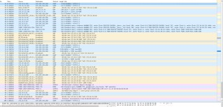

**2.Create a Filter to display only TCP/UDP packets, inspect the packets and provide the flow graph.**

**Procedure**

∙ Select Local Area Connection in Wireshark.

∙ Go to capture option

∙ Select stop capture automatically after 100 packets.

∙ Then click Start capture.

∙ Search TCP packets in search bar.

∙ To see flow graph click StatisticsFlow graph.

∙ Save the packets.

**Output:**

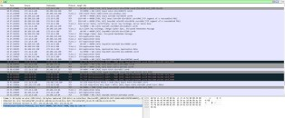

**Flow Graph output**

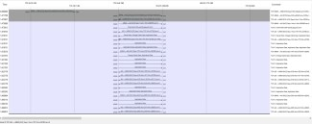

**3.Create a Filter to display only ARP packets and inspect the packets. Procedure**

∙ Select Local Area Connection in Wireshark.

∙ Go to capture option

∙ Select stop capture automatically after 100 packets.

∙ Then click Start capture.

∙ Search ARP packets in search bar.

∙ Save the packets.

**Output**

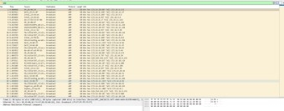

**4.Create a Filter to display only DNS packets and provide the flow graph. Procedure**

∙ Select Local Area Connection in Wireshark.

∙ Go to capture option

∙ Select stop capture automatically after 100 packets.

∙ Then click Start capture.

∙ Search DNS packets in search bar.

∙ To see flow graph click StatisticsFlow graph.

∙ Save the packets.

**Output**

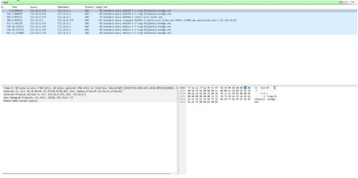

**Flow Graph output**

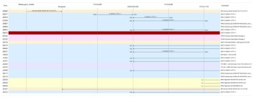

**5.Create a Filter to display only HTTP packets and inspect the packets Procedure**

∙ Select Local Area Connection in Wireshark.

∙ Go to capture option

∙ Select stop capture automatically after 100 packets.

∙ Then click Start capture.

∙ Search HTTP packets in the search bar.

∙ Save the packets.

**Output**

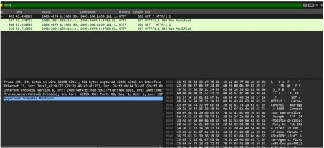

**Flow Graph output**

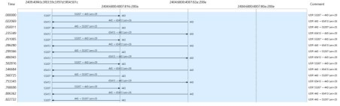

**6.Create a Filter to display only IP/ICMP packets and inspect the packets. Procedure**

∙ Select Local Area Connection in Wireshark.

∙ Go to capture option

∙ Select stop capture automatically after 100 packets.

∙ Then click Start capture.

∙ Search ICMP/IP packets in search bar.

∙ Save the packets

**Output**

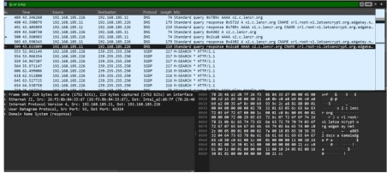

**Flow Graph output**

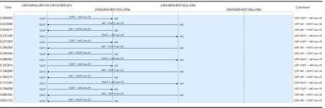

**7.Create a Filter to display only DHCP packets and inspect the packets. Procedure**

∙ Select Local Area Connection in Wireshark.

∙ Go to capture option

∙ Select stop capture automatically after 100 packets.

∙ Then click Start capture.

∙ Search DHCP packets in search bar. ∙ Save the packets

**Output**

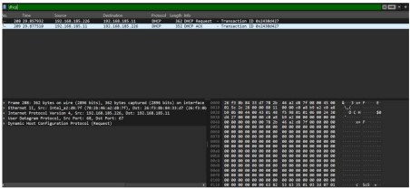

**RESULT:**

Hence,analyzing network traffic using Wireshark Tool is studied